2D PARTICLE
EDITOR
Particle effect
What Is A Particle Effect?
A particle effect consists of some images that are moved around.

Some Features Of A Particle Effect With 2d Particle Editor.
- The images usually use additive blending and some pretty stunning results can be produced with only a few images.
- You can also create effects programmatically, but it is much more difficult and time consuming to create great effects.
- Each particle has many properties that control how it behaves: life, velocity, rotation, scale, etc.

2d particle editor
How To Use It?
Step 1

- Create a new lib-gdx project from scratch like the image.

- Is really important to mark tools checkbox because there will be the 2D Particle Editor.

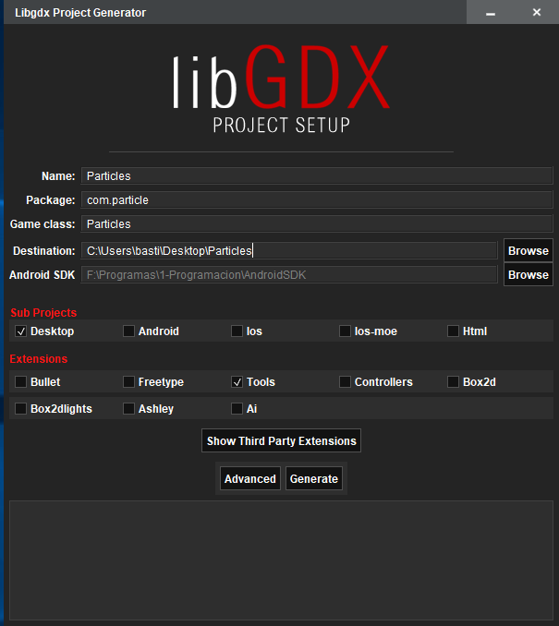

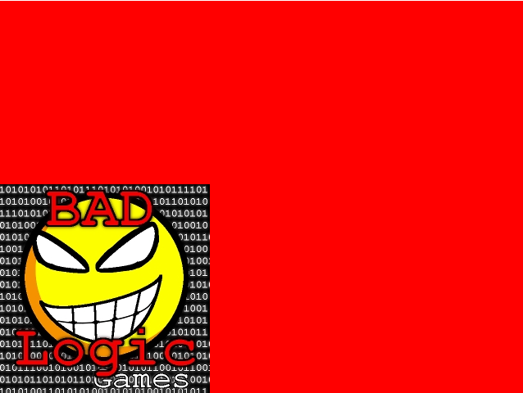
2D PARTICLE EDITOR
How To Use It?
Step 2

- Go to Run→ Edit Configurations→ Working Directory and select the folder core/assets of your project.

- Run the project to be sure it works right. (You should see the logo of lib-gdx like the image)

2d Particle Editor
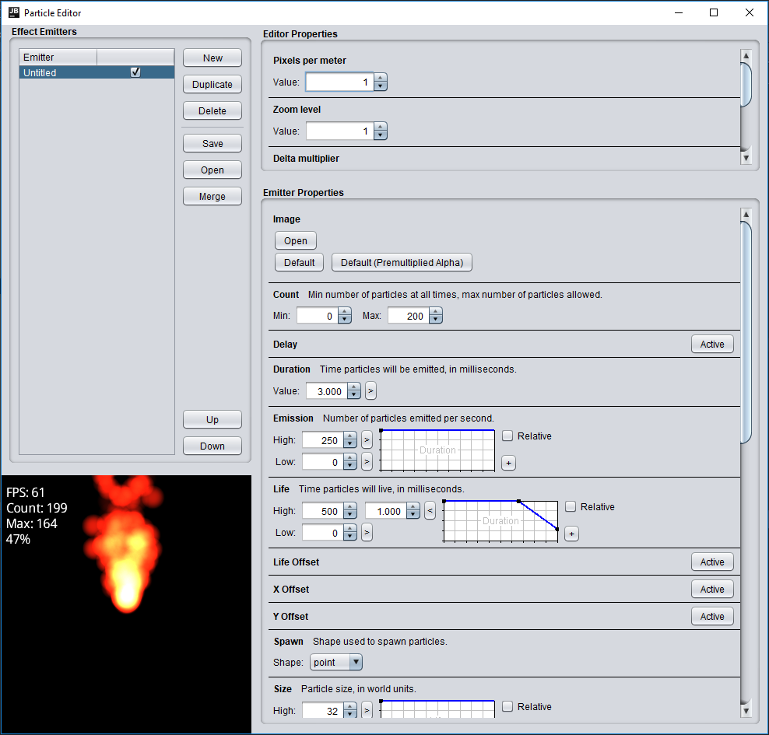
How To Use It?
Step 3
- Go to External Libraries -> com.badlogicgames.gdx:gdx-tools:1.9.6 -> gdx-tools-1.9.6.jar -> com-badlogic.gdx -> tools ->particleeditor.
- Right click ParticleEditor and Run ‘ParticleEditor.main()’.
- At Use classpath of module select Desktop.
- When you run the project you should see something like the image.
- Create your custom particle effect as you like and save it in your core/assets folder.
- Once we created your first particle effect is time to use it.

2D Particle Editor
How To Use It?
Step 4
Let’s edit our class Particles.java to see the particle effect.
First create a new variable of the kind ParticleEffect and import the library com.badlogic.gdx.graphics.g2d.ParticleEffect.
Now edit our create method and replace the code for the following:

batch = new SpriteBatch();

particleEffect = new ParticleEffect();

particleEffect.load(Gdx.files.internal("nameOfTheParticleEffect"),
Gdx.files.internal(""));

particleEffect.getEmitters().first().setPosition(
Gdx.graphics.getWidth()/2,
Gdx.graphics.getHeight()/2);
particleEffect.start();

2D Particle Editor
How To Use It?
Step 5
The last step is edit our render method to see in our first particle effect.

Gdx.gl.glClearColor(0, 0, 0, 1);
Gdx.gl.glClear(GL20.GL_COLOR_BUFFER_BIT);

particleEffect.update(Gdx.graphics.getDeltaTime());
batch.begin();
particleEffect.draw(batch);
batch.end();

Run DesktopLauncher and you will see the particle effect only works for few seconds, if we want to see it until the game ends add the following code at the end of the render method.

if(particleEffect.isComplete())
particleEffect.reset();

